**NAVAJEEVANA GRAMEENA ABHIVRIDDHI SAMSTHE, MUDGAL**

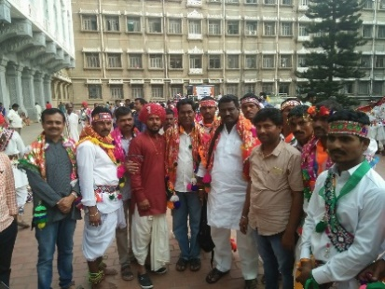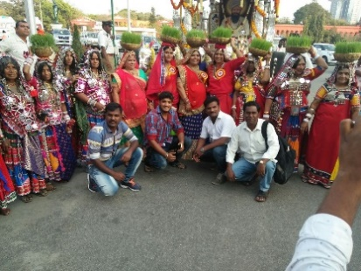

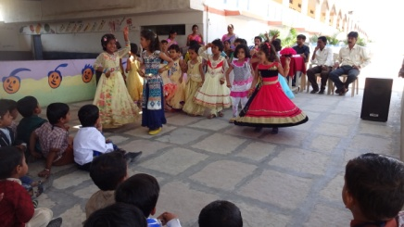

**ANNUAL REPORT 2017 - 2018**



**# 14-4-207 Begaumpurpet, Above SBI Mudgal Branch, Mudgal – 584 125,**

**Lingsugur Taluk, Raichur District – KARNATAKA**

|  |
| --- |
| ANNUAL REPORT 2017-18  (Annual Report period from 1st April 2017 to 31st March 2018) |

**NGAS** was established in 2001and was registered under Registration of Societies Act 1960 bearing No.: 88/2001-02 and has 80G/12A/ PAN CARD. NGAS is also registered under Ministry of Home Affairs under Foreign Contribution Regulation Act (FRCA).

**Vision** of the organization is to see that there is humane, harmony in the community where its people live with dignity, fulfill basic amenities, well informed citizens and where there is an equal opportunity, social justice prevails and free from exploitation whatsoever.

**Mission** is to organize, empower the communities that are marginalized and vulnerable and facilitate them to participate equally and take ownership of their own development.

In order to fulfill the above vision and mission in mind the organization started in 2001 for the purpose of empowerment of SC/ST,OBC and other marginalized people. This is one of the most backward districts in the State. The organization working in most backward areas and working to improve on socio-economic, educational and cultural upliftment of the excluded people. All development indicators depict dismal picture in Raichur district. It is the first from the bottom at State level. This is the situation, the organization trying to develop from the scratch.

This year NGAS has been collaborated with KVT – GOK – Vocational Training and GOONJ – Material, Shoes, Clothes, Cloth Pad distribution to address menstrual hygiene for the women and adolescent girls in the villages and towns.

The organization working for the past 18 years and in 68 villages of Lingsugur and Maski Taluks of Raichur District, Hungund Taluk of Bagalkot District, Karnataka. During the reporting period the following activities have been carried out in the organization. I am happy to present to the board.

**1. Anganwadi Kit, Shoe and play materials distributed to Anganwadi Centres:** This programme was carried out in collaboration with Goonj organization. There were 25 Anganwadi centres have been covered. Shoe and play materials distributed to 648 children. There were 356 Girls and 292 boys benefited. This has motivated the anganwadi teacher first and the children come to anganwadi centre for play and learn. As a result, drop out in Anganwadi centre has been reduced considerably and hygiene improved.

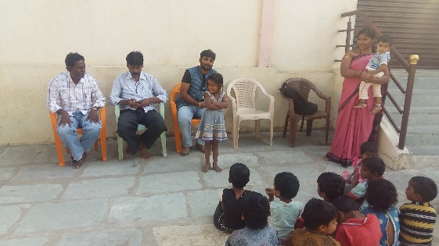 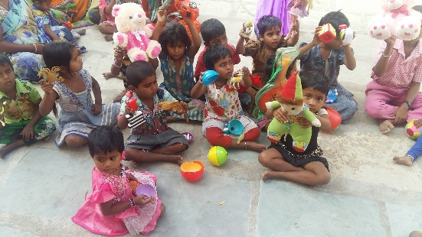 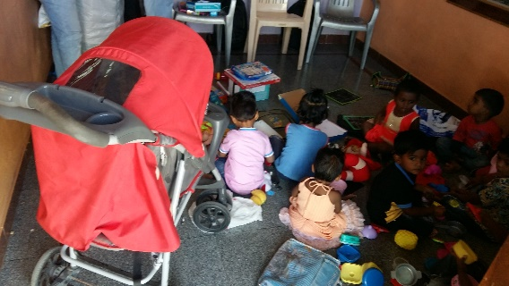

**2. School Material and kits distributed:** This was done in collaboration with Goonj organization. School bags, school kits have been given to children from socio-economic deprived studying in 30 Govt. schools in an around Lingsugur and Bagalkot Taluks. There were 2032 children benefited. [Girls - 1209, Boys - 823].

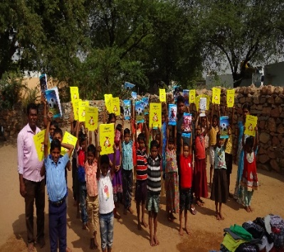 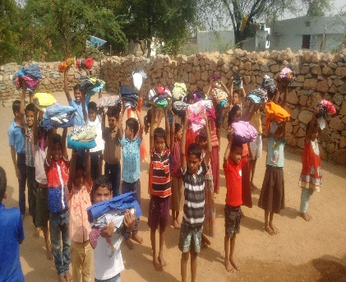 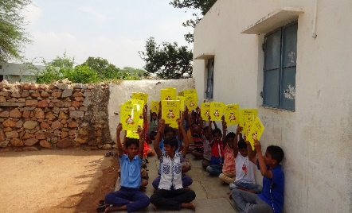

**3. Cloth for Work Programme and shoe distribution:** Cloth for work programme was carried out with the support of Goonj, Delhi. It was implemented in Ramatnal, Kadatharahall, Kadatharahall Thanda, Krishnapur, Talekattu, Adapur, Ankanal, Vandli and Mattur villages. The village people identify the work on priority basis and work done by the villagers. Instead of wage cloth distributed. This has honour and dignity of the labour. There were **1605 family kit** distributed and more than **10,000 family members** have been benefited.

Shoe distributed in schools and boarding. There were **7700 shoes distributed**. **Girls – 4620, Boys – 3080** have been benefited. This shoe has been distributed as a token of work done by the students. This will honor the student’s work and it has motivated students to involve in extra curricular activities and has improved their socialization and communication skills.

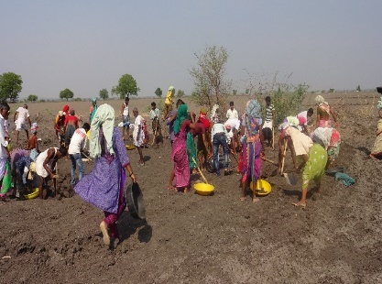 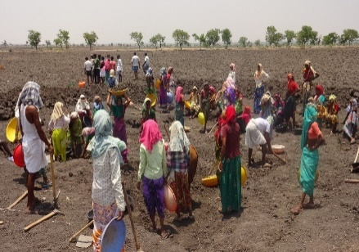 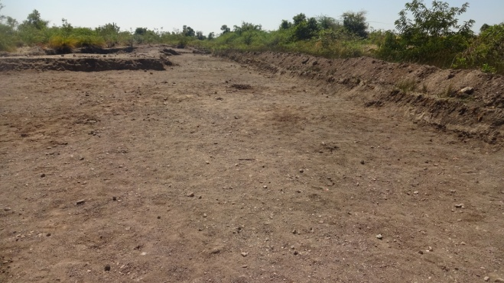

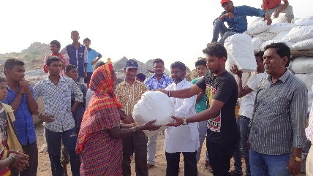 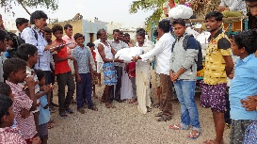 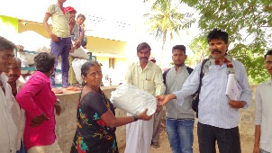

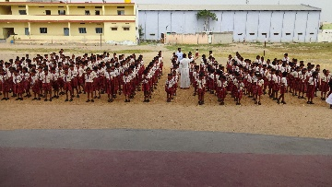 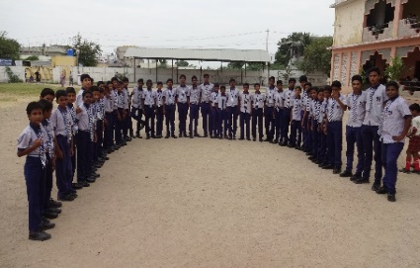 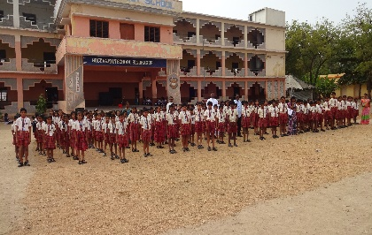

**4. Not Just a Piece of Cloth [NJPC] Programme:** This was conducted in collaboration with Goonj organization. This has helped the teenage girls to understand their menstrual hygiene and how to keep them safe and healthy during their periods. There were **350 adolescent girls** hasbeen benefited. This has enhanced the understanding of menstrual hygiene and improved their reproductive health.

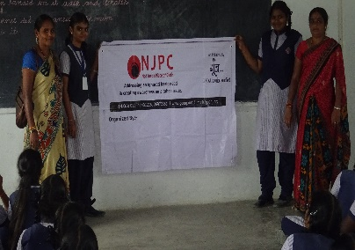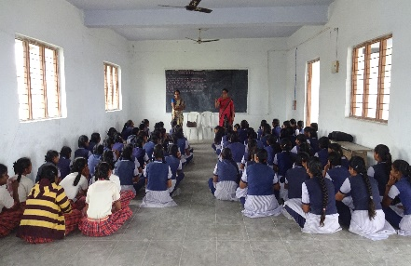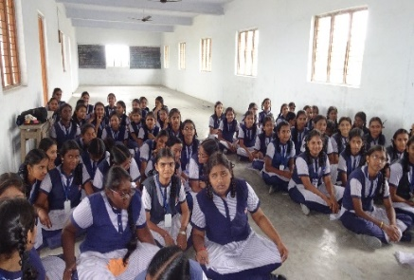

**5. Nutritional Support**: NGAS have identified dropout children in the villages. They have been brought to bridge school. In the bridge school NGAS have provided nutritional support to **100 children both girls and boys, since they are deprived of nutritional food** in their homes. This children hails from poor socio-economic status. As a result, the children’s nutritional food intake has been improved and they are concentrating in their studies. After 12 months of stay they have been mainstreamed into normal school. 100% of children enrolled into school. Now they are studying Govt. school and they have improved in their studies.

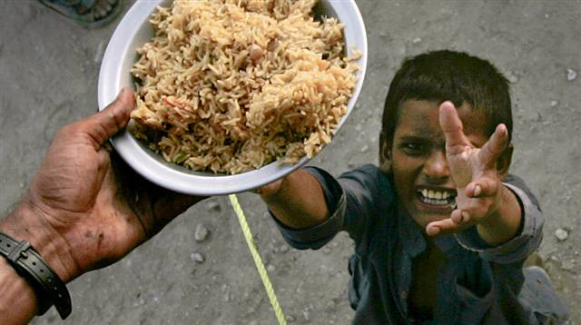 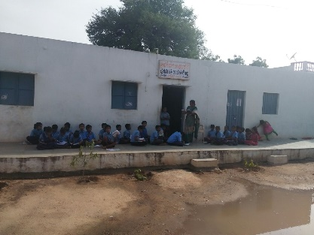 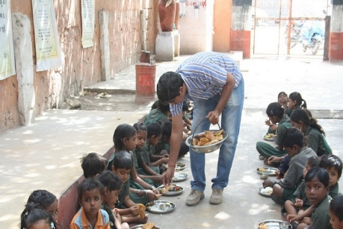

**6. IEC Materials produced:** Information is power**.** In order to improve the information for the general public the following materials have been produced and distributed to them through hand bills, banner and it has been reached to every household through local daily news paper. Information imparted on “Swacch Bharath Camapign’’. Organisation collaborated with the GP and it has been implemented in **7 GPs** viz, **Mattur, Kannal, Hunuru, Baanigolu, Amdihal, Medikinal, Nagalapur GPs and 23 wards of Mudgal Municipality**. Drinking water, garbage disposal conservation of water and environment, how to use the electricity effectively communicated to the village and town people. Support provided to construct toilet in the houses. There were **350 people availed the toilet construction facility**. As a result, the personal hygiene improved and open defecation in a down trend. More over awareness imparted on 100 days MGNREGA objectives and its purpose.

**7. EDP Training:** Phenol and soap making training imparted to the 180 women. As a result, the 60 women started their own micro enterprises and their family income has been increased.

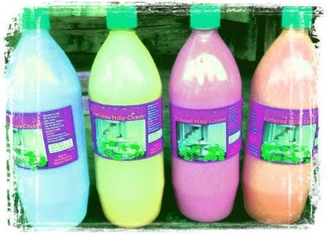 

**8. Street Play on Health:** NGAS did street play on health concept (Prevent open defecation and improve sanitation). If any disease comes immediately have to see the doctor, communal harmony, promote social justice, safe drinking water, safe disposal of solid wastage, how to control mosquitoes and how to protect from mosquitoes and this been imparted through street play, drum beating,Yakshakana, folk song, awareness song, dance and cultural shows. This has been reached **5,000 population from 16 wards of Mudgal Municipal area.** This has been carried out in collaboration with Mudgal Municipality and it has been done from August 13 to 20th 2017. This street play has been conducted where the general public gathered in one place such as bus station, community hall, circle and the temples. The women gather in community hall, SHG meeting times and the temples. This has been imparted to men, women and children.

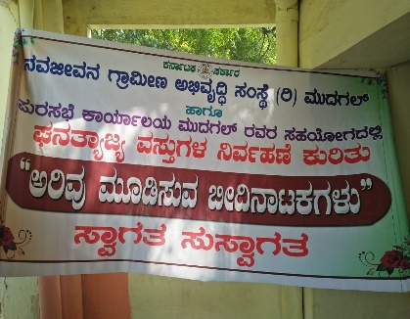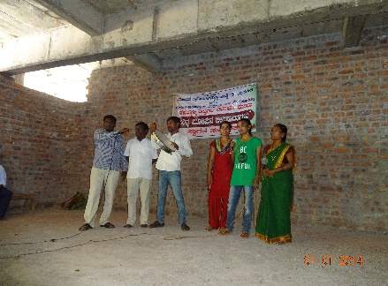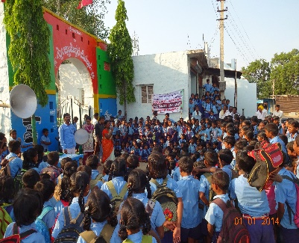

**9. Rain Water Harvesting Programme**: In order to utilize the rain water 100% rain water harvesting programme have been organized since this is the drought prone area. Dry land agriculture and crop have been adopted here. In this programme farmer (male and female), likeminded youths are included. In that meeting the successful farmers are invited to deliver address so that they can be inspired and used the rain water harvesting technique to them. He also addressed how to cultivate low water consumption crop and get more yield. This was conducted from January 15 to 25, 2017. There were **110 farmers** have been participated **from 12 villages**. As a result, now they are using rain water harvesting techniques and cultivating low water consumption crops and getting more yields.

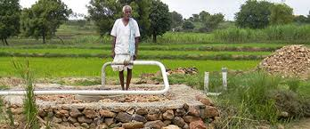 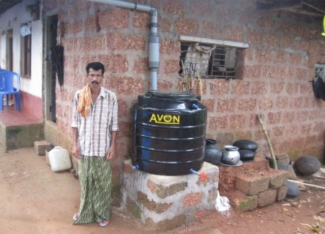 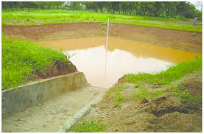

**10. National days and week celebration**: In order to remember the National days among the general public and office staff this was celebrated. The important days being celebrated were: Republic Day, Independence Day, Gandhi Jayanthi, Teacher’s day, Children’s day, Karnataka Rajyothsava, Ambedkar Jayanthi, and Kanakadasha Jayanthi. The purpose of celebration was that to deliver the importance of the day and in what circumstance we have got this day and keep them in national main stream. Through this SHG members, youths, school children, teachers, respected elders from the villages and NGAS staff have been participated in the celebration.

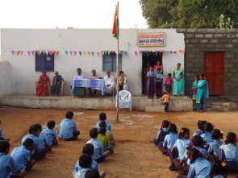 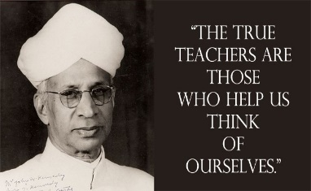  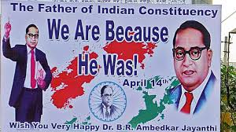

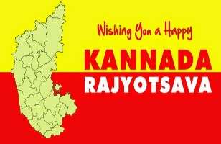 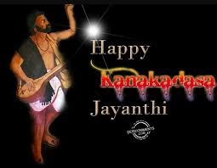 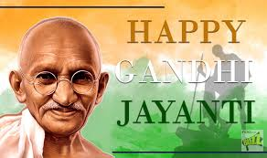

**11. Beauty Parlour:** There were two batches of training held. 30 members each per batch and in all **120 women have been benefited**. After the training certificate issued and 60% of women employed profitably and 40% of women running beauty parlour shop on their own and they also provide employment to other women in the villages.

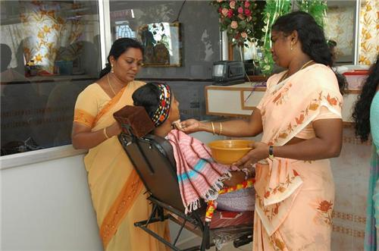  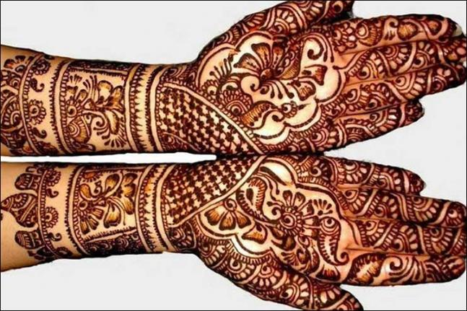

**12. Shramadan**: In order to show to the community to contribute to the society by way of small contribution. To demonstrate the people, NGAS staff has done voluntary services to clean the dhobi ghat, cleaning of streets, cleaning of school ground for model purpose and the ward general public also joined. This was done in 3 **villages** of Lingsugur Taluk. In all **260 members** were participated in it. As a result, Dhobi Gahat, street and school ground has been cleaned and their health condition have been improved. We have asked the people to do it frequently as we done as a model. Have to continue the model work we have been initiated and keep the surroundings neat and tidy so that expense towards health can be reduced considerably.

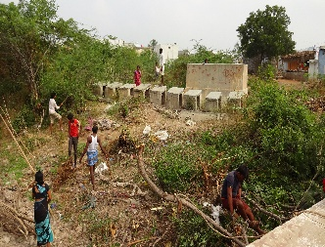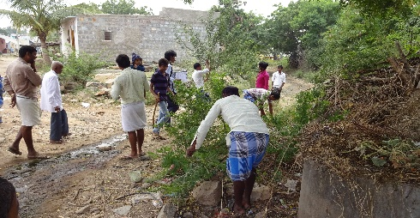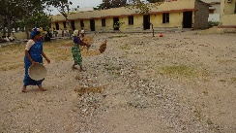

**13. Computer Training and Education Centre**: NGAS have registered under Vocational Training Provider under Government of India, Department of Employment and Training. Vide Reg. No.: 529060017. **Through VTP the organization trained 240 members of which 96 men and 144 women in Computer**. NGAS has 20 computers on its own and has imparted training to the students, employed and un-employed youths. So that it would enable them to build their skills and after the training they can able to get better employment opportunity and get decent salary. NGAS have appointed one computer teacher for the purpose. NGAS have plans to develop this centre as Information Technology Enabled Services (ITES) to the rural people. We are looking forward to have some collaborators/ donors for the purpose.

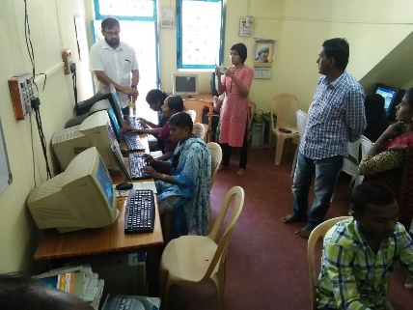 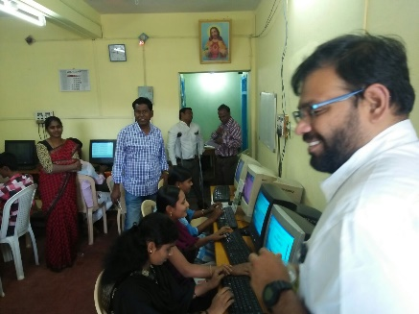 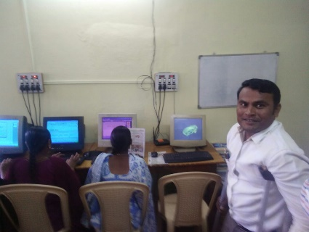

**14. Staff Member Training**: In order to equip the staff, training provided to them. The training focused on Global warming, organic farming and alternative source of energy, communication skills and personality development. How to translate our weakness into strength, how to identify the issues in the public and how to address with the support of the general public. The resource persons were drawn from NGOs from Bangalore and Mysore districts. There were **10 staff** have been benefited.

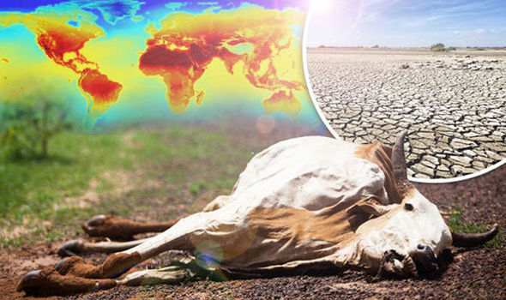 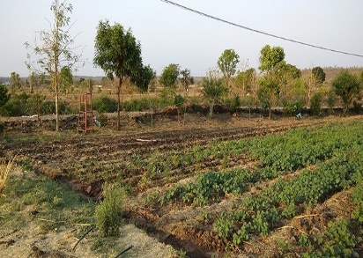 

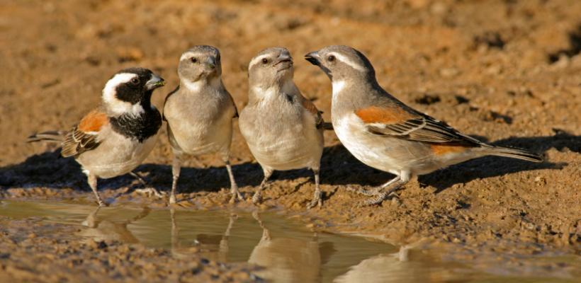

**15. Garments Training**: Tailoring training provided to un-employed women by the NGAS on its own source. Under self-employment training, **60 un-employed women** have been identified and training imparted. This was 6 months training. It was carried out from August 2017 to January 2018. After the training certificate provided and imparted information on bank linkage, garments production and marketing details have been imparted. Now **50 women are doing saree falls, embroidery and stitching blouse and children dress.** As a result, women are supplementing their family income. Rest of the women got married and settled in their life.

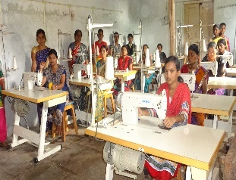 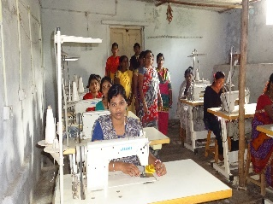 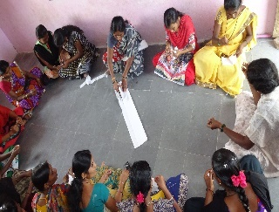 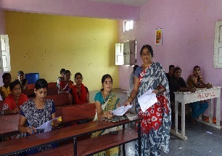

**16. Participated in State level NGO Federation meeting: NGAS** became member of various State level networks such as CACL-K, CACT-K, Right to Food Network. NGAS participated in State level NGO Federation meeting and it was held on 19th November 2017 at Tumkur University. In that meeting FCRA, Local contribution, linking with various line Govt. departments, various Acts related to NGOs and FCRA have been discussed. The Federation send all information to member organizations periodically about the fund available at Govt, CSR projects.

**17. Participated in North Karnataka & District level NGO Network meeting:** NGAS became part of North Karnataka and District level NGO Network. NGAS participated in North Karnataka NGO network meeting held once in three months and NGAS is regular participant in NGO Network meeting. It was held in Raichur, Mudgal, Manvi and Sindanur respectively. District level NGO network meeting participated. Once in three months on 5th day of the third month meeting have been fixed. In that meeting what were the source of funding available to NGOs, how to access them and given guidance for technical support for the same. What are the Government schemes available, what are the formats for that and how to apply them has been imparted. How to mobilize fund for NGOs how to write effective project proposal also imparted for NGOs**.**

**18. TMC: “Swaachha Bharatha Campaign’’** has been hand over to NGAS and it collects door to door garbage and it has reduced the garbage in the street and it has induced the hygiene among the family members. In 23 wards door to door garbage collection done by NGAS. It was supported by the Mudgal Municipality.

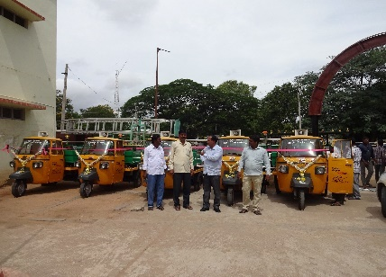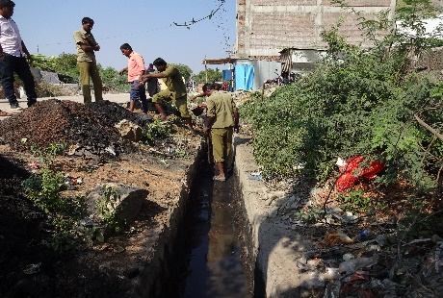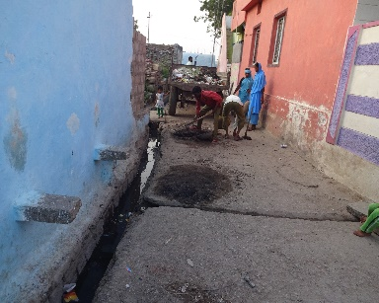

**19. Sustainable Agricultural Programme:** Information imparted to farmers on climate change, dry land agricultural practices, organic/ natural farming practices. More over dry land, sericulture and horticulture crops also profitable to the farmers. **It was conducted in hobli, GP level and 4 programmes conducted.** There were **120 farmers have been participated**. As a result, the farmers aware of the climate change and global warming and accordingly they cultivate crops in their field.

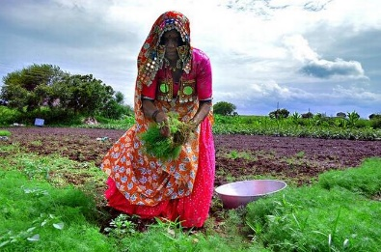 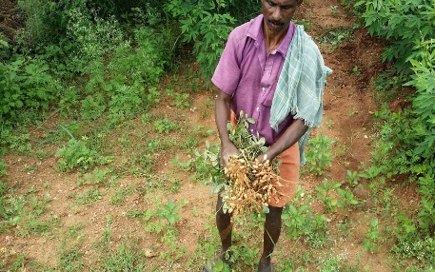 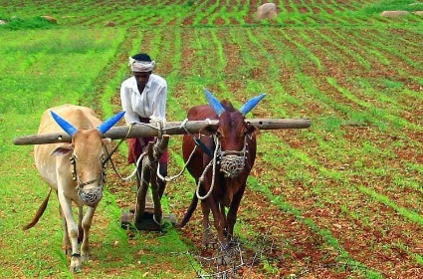

**20. Karnataka State Wakf Foundation – Bangalore**: **Computer and Tailoring** training conducted under this head. There were 75 Muslim women trained in computer and 75 Muslim womentrained in Garments and after the training certificates distributed to them. All are women only. As a result, 23% of the trainees engaged in small enterprises and rest of them profitably employed in other works.

**21. PACNI - INDIA Programme:** NGAS has participated in Pastrol Care for Nomads India (PACNI) – National meet held at Bhopal on 11th and 12th March 2018 which was conducted by PACNI National wing. Have worked out action plan for Karnataka and also presented Karnataka case for National wing support. The President and Project Coordinator of NGAS has been attended the meeting. It was enabled NGAS to spread its wings to the National level for networking and policy making at National level for the development of Nomads community.

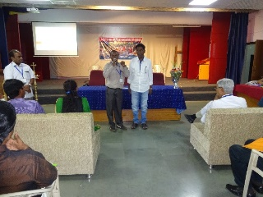 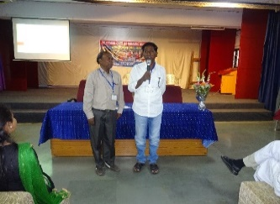 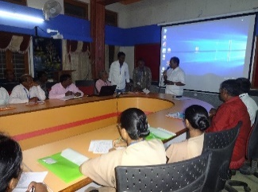 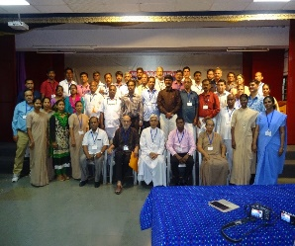

**22. Participated in Banjara Federation meeting at District and State Level:** District level meeting held at Maski on 4th March 2018 and the State level meeting held at Bangalore on 15th February 2018. It enabled the NGAS to built contact with the District and State level network organizations and bring pressure on the Govt. for better implementation of development schemes exclusively for Banjara community.

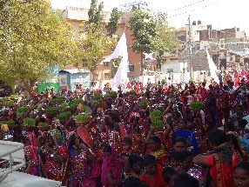 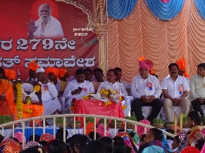 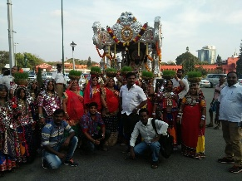 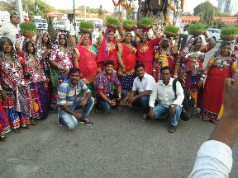

**23. Participated in State level Seminar on CSR: Opportunities and Challenges for NGOs and Corporate:** Whichwas jointly organized byInstitute for Youth and Development (IYD) and Department of studies and Research in Social Work, Tumkur University with the support from Vishwa Yuvak Kendra (VYK), New Delhi. It was held on 18th and 19th November 2017 at the Tumkur University Auditorium. It has enabled NGAS to build rapport and contact with CSR companies for resource mobilization.

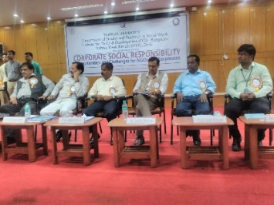 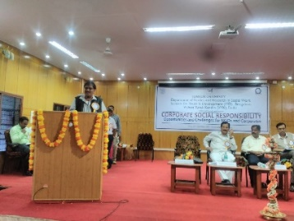 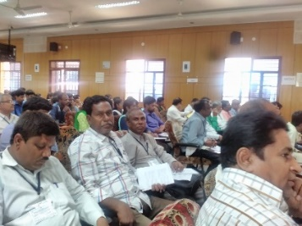

**24. Participated in Goonj 2 decades celebration in Bangalore:** NGAS is one of the partner organizations of Goonj. It has celebrated its 3 decades of completion of service in India and it was held in Bangalore on 7th March 2018. NGAS and its team members have been part of the programme.

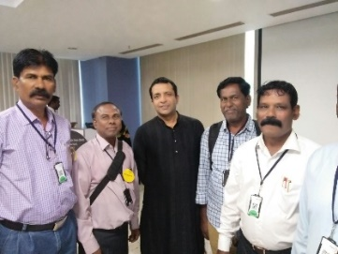 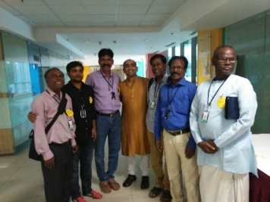

**25. GAP Team visited for feasibility funding to NGAS**

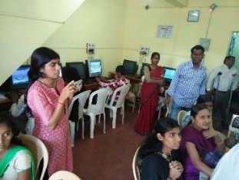 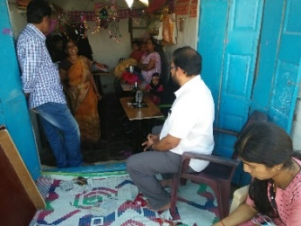 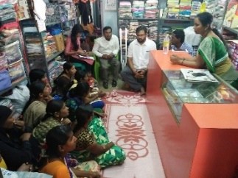 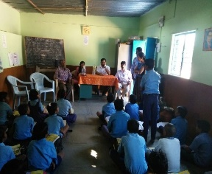

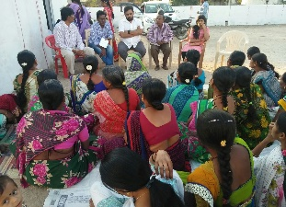 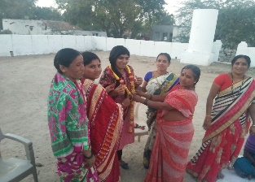 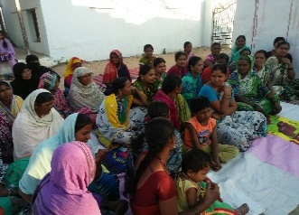 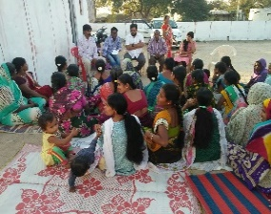

Global Action on Poverty [GAP] team members visited to NGAS on 3rd February 2018 for assessing and see the field reality of NGAS skill building carried out for the past 5 years. The team had visited all skill building centres and had interaction with various stakeholders to assess the impact of the programme and also venture out various activities for funding. The visit enabled the team members to understand the NGAS work and venture out of resource mobilization for NGAS.

We are received Rs.3,17,385/- from Klaas Oskam Managing Director of Signal Hill Organisation through GAP. From this amount NGAS purchased 9 computers and installed the same for training of more number of candidates in Mudgal Computer Training Centre. NGAS acknowledges with gratitude the donation made by the Signal Hill Organisation through GAP.

President

NGAS

Mob. No.: +91 9448825470/ 9481364182

**************************